Course Design Worksheet
(Adapted from: International Council for Higher Education)

Title of the course:

Interdomain Domains & disciplines to be included: (a)

Linked (b)

What is the big question for this integrative course (in one or two sentences)?
Example 1: What determines the level of schooling people complete? (with perspectives from Education and Economics)
Example 2: How is breakfast related to increased brainpower? (with perspectives from Biology and Psychology)
Example 3: To raise or not to raise the minimum wage? (with perspectives from Economics and Justice Studies)

Which 2-4 of the seven Gen-Ed Learning Objectives will be emphasized in the course?
Select from this list (see also Appendix A):
- Effective Communication
- Key Literacies
- Critical/Analytical Thinking
- Integrative Thinking
- Creative Thinking
- Global Learning
- Social Responsibility & Ethical Reasoning

Which Student Learning Criteria (minimum of 3) will be addressed per domain?
(select from lists in Appendix A)

Explain how the scientific approaches and interests of the two knowledge domains will be addressed in the course and practiced by the students.

What does the research in discipline 1 focus on when addressing this big question?

What does the research in discipline 2 focus on when addressing this big question?

How might the two disciplines benefit from each other and generate a more complete analysis of the problem?

What strategies and activities will you use to help students practice integrative learning?
(see Appendix B)

Course-level Learning Outcomes:
Given the specifics of your course(s), which specific learning outcomes do you consider most important?
Frame your course outcomes in view of the chosen Gen-Ed Learning Objectives (see p. 1 above) and consider different levels of learning, including comprehension, application, and integration of content!

- Comprehension: What key information and ideas are important for students to understand and remember? (just a couple of broad sentences!)

- Application: What kinds of skills and ways of thinking do students need to learn?
(just a couple of broad sentences!)

- Integration A: What connections should students recognize and make between the two disciplines? (i.e., connections between ideas in the two disciplines!)

- Integration B: What—if any—connections should students recognize and make between the course and their own life? (i.e., connections between ideas from the two disciplines and students’ own lives!)

- Integration C: What connections should students recognize and make between course content and the broader social context within which they live? (i.e., connections between ideas from the two disciplines and contemporary society!)

Learning Actions:
Each learning action is aligned with a corresponding learning outcome. Answer the following questions to form appropriate actions.

- What sources, data, lectures, and texts will be used for the receiving of information and ideas? (i.e., knowledge acquisition)

- What kinds of doing and observing will be used for developing skills and thinking? (i.e., practicing specific skills)

- What type of active reflection will be used for making connections between the two disciplines? (i.e., reflection of how the two disciplines are connected)

- What type of active reflection will be used for building connections between content and students’ lives? (i.e., reflection on how students’ lives are connected to the two disciplines)

- What type of active reflection will be used for building connections between content and the broader social context? (i.e., reflection of how society as a whole is connected to the two disciplines)

Key Assignment:
Does the course have one or more key assignments? Earlier today, you already identified a main assignment. You may use the same assignment again, or create a new one. Answer the following questions:

What is the topic of the assignment and its intended purpose?

How much time do you give students to finish the assignment?

What types of periodic feedback (if any) will students receive while working on the assignment?

Who is the (presumed) audience for this assignment?

Which aspects of your course’s integrated disciplines are your students expected to address?

What role should student-reflection and self-assessment play? In what form should they be expressed?
Assessment Techniques:
Each assessment procedure evaluates the degree to which the student has met the corresponding objective. Answer the following questions to structure appropriate forms of assessment. When finished, share your ideas with a colleague or two:

- How will students’ understanding of key information and ideas be assessed?
(e.g. with quizzes and tests)

- How will students’ application of thought and skills be assessed?
(e.g. with tests, roleplays, case studies)

- How will students’ recognition of connections between the two disciplines be assessed?
(e.g. with short essay tests or course projects)

- How will students’ recognition of connections between content and their own life be assessed?
(e.g. with reflection activities, such as reflective journaling)

- How will students’ recognition of connections between content and the social context be assessed?
(e.g. with reflection activities and a course project)
Course Alignment Worksheet

Course-level Outcomes:  Understand and remember key information and ideas | Learning actions:  Receive information and ideas | Assessment:  Understanding of key information and ideas
Course-level Outcomes:  Learn skills and ways of thinking | Learning actions:  Doing and observing experiences | Assessment:  Application of thoughts and skills

Course-level Outcomes:  Make connections between ideas, self, and society | Learning actions:  Active reflection upon new information and experiences | Assessment:  Recognition of connections between ideas, self, society

Responsibilities for Co-Instructors in Linked Courses only:
Upon developing the syllabus, use the following questions to review the instructor responsibilities:

- What responsibilities will be shared by the instructors?

- What responsibilities will be divided generally (across the semester or term) and specifically (on particular days)?

  - What are the responsibilities of the instructor “in charge” of a particular event or assignment?

  - How can the other instructor(s) facilitate student learning by assisting the instructor with the primary responsibility for a given event or assignment?

- How will instructors handle disagreements about content or procedure without undermining one another or compromising student learning?

- How and when will instructors meet to discuss the course and consider changes to content or procedures throughout the semester?

----------------------------------------------------------------------------------------------------

For all Faculty: Develop a Syllabus:
Address the details of the course by developing a syllabus with daily plans.

Integrative Learning Rubric (AAC&U)
Simplified Criteria and one Performance Level

PERFORMANCE CRITERIA: | PERFORMANCE LEVEL (high): | YOUR NOTES:
Connections to Experience:  Connects relevant experience and academic learning | Effectively selects and develops examples of life experiences, drawn from a variety of contexts (e.g., family life, artistic participation, civic involvement, work experience) to illuminate concepts, theories, or frameworks developed in academic learning.
Connections to Discipline:  Makes connections across disciplines and/or perspectives | Independently connects examples, facts, or theories from more than one field of study, discipline or perspective.
Transfer:  Adapts and applies skills, abilities, theories, or methodologies gained in one situation to new situations | Adapts and applies skills, abilities, theories, or methodologies, gained in one situation to new situations to solve problems or explore issues.
Integrated Communication:  Makes strategic and meaningful communication choices across multiple contexts and purposes (professional, academic, and civic) | Choices of language or other modes of expression, within individual performances of tasks, demonstrate awareness of and calibration toward purpose and audience.
Reflection and Self-Assessment:  Demonstrates a developing sense of self as a learner, building on prior experiences to respond to new and challenging context (may be evident in self-assessment, reflective, or creative work) | Evaluates changes in own learning over time, recognizing complex contextual factors (e.g., work with ambiguity and risk, deals with frustration, considers ethical frameworks.

Adapted from The Washington Center for Internships and Academic Seminars

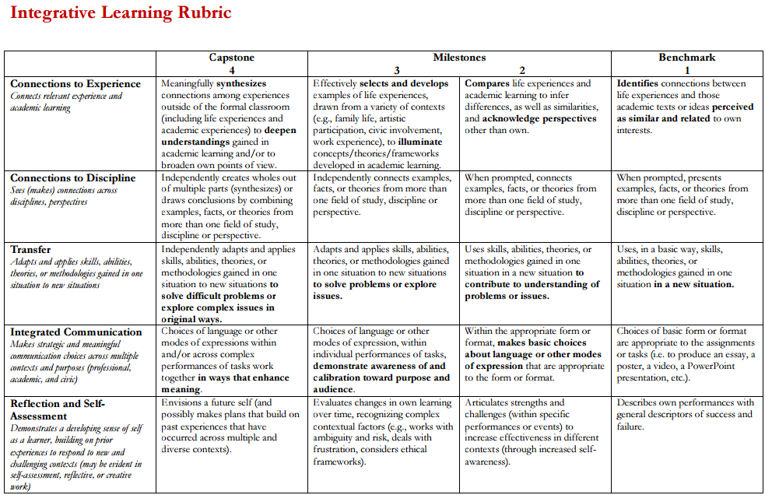
Slightly adapted from AAC&U Integrative Learning Rubric

